**ASSIGNMENT HTML/ CSS**

**Chirag Kumar Sharma**

1. **How are inline and block elements different from each other?**

A block-level element always starts on a new line. A block-level element always takes up the full width available (stretches out to the left and right as far as it can). A block level element has a top and a bottom margin, whereas an inline element does not.

Eg <div>

An inline element does not start on a new line.An inline element only takes up as much width as necessary.

Eg <span>

1. **Explain the difference between visibility:hidden and display:none**

display:none means that the tag in question will not appear on the page at all (although you can still interact with it through the dom). There will be no space allocated for it between the other tags.

visibility:hidden means that unlike display:none, the tag is not visible, but space is allocated for it on the page. The tag is rendered, it just isn't seen on the page.

1. **Explain the clear and float properties.**

The float property is used for positioning and formatting content e.g. let an image float left to the text in a container.

The float property can have one of the following values:

* left - The element floats to the left of its container
* right - The element floats to the right of its container
* none - The element does not float (will be displayed just where it occurs in the text). This is default
* inherit - The element inherits the float value of its parent

In its simplest use, the float property can be used to wrap text around images.

The clear property specifies what elements can float beside the cleared element and on which side.

The clear property can have one of the following values:

* none - Allows floating elements on both sides. This is default
* left - No floating elements allowed on the left side
* right- No floating elements allowed on the right side
* both - No floating elements allowed on either the left or the right side
* inherit - The element inherits the clear value of its parent

The most common way to use the clear property is after you have used a float property on an element.

1. **Explain difference between absolute, relative, fixed and static.**

STATIC

This is the default for every single page element. Different elements don’t have different default values for positioning, they all start out as static. Static doesn’t mean much; it just means that the element will flow into the page as it normally would.

RELATIVE

 If you set position: relative; on an element but no other positioning attributes (top, left, bottom or right), it will have no effect on it’s positioning at all, it will be exactly as it would be if you left it as position: static; But if you *do* give it some other positioning attribute, say, top: 10px;, it will shift its position 10 pixels *down* from where it would *normally* be.

ABSOLUTE

This is a very powerful type of positioning that allows you to literally place any page element exactly where you want it. You use the positioning attributes top, left, bottom, and right to set the location. Remember that these values will be relative to the next parent element with relative (or absolute) positioning. If there is no such parent, it will default all the way back up to the <html> element itself meaning it will be placed relative to the page itself.

FIXED

A fixed position element is positioned relative to the *viewport*, or the browser window itself. The viewport doesn’t change when the window is scrolled, so a fixed positioned element will stay right where it is when the page is scrolled.

1. **Write the HTML code to create a table in which there are 4 columns( ID , Employee Name, Designation, Department) and at least 6 rows. Also do some styling to it.**
2. <html>
3. <head>
4. <title>Tables in HTML</title>
5. <style>
6. table, th, td {
7. border: 3px solid black;
8. border-collapse: collapse;}
9. th, td {
10. padding: 15px;}
11. th {
12. text-align: left;}
13. #ttt {
14. background-color: greenyellow;}
16. #tt {
17. background-color: yellow;}
18. tr:hover {
19. background-color: #f5f5f5;}
20. </style>
21. </head>
22. <body>
23. <h1>Employee Table</h1>
24. <table style="width:50%">
25. <tr id="tt">
26. <th>ID</th>
27. <th>Employee Name</th>
28. <th>Designation</th>
29. <th>Department</th>
30. </tr>
31. <tr id="ttt">
32. <td>123</td>
33. <td>Chirag Kumar Sharma</td>
34. <td>Trainee</td>
35. <td>IT</td>
36. </tr>
37. <tr id="ttt">
38. <td>334</td>
39. <td>Harshit Abrol</td>
40. <td>Trainee</td>
41. <td>IT</td>
42. </tr>
43. <tr id="ttt">
44. <td>987</td>
45. <td>Nowsheen Ishtiyaq Mufti</td>
46. <td>Trainee</td>
47. <td>IT</td>
48. </tr>
49. <tr id="ttt">
50. <td>9309</td>
51. <td>Shivam Sharma</td>
52. <td>Trainee</td>
53. <td>IT</td>
54. </tr>
55. <tr id="ttt">
56. <td>8812</td>
57. <td>Saurabh Aroro</td>
58. <td>Trainee</td>
59. <td>IT</td>
60. </tr>
61. <tr id="ttt">
62. <td>439</td>
63. <td>Prajjwal Rajesh</td>
64. <td>Trainee</td>
65. <td>IT</td>
66. </tr>
67. </table>
68. </body>
69. </html>

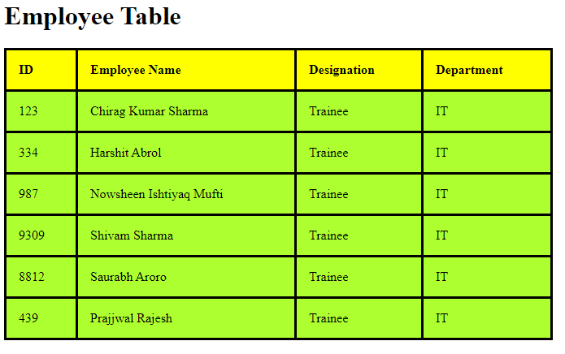

**6. Why do we use meta tags?**

Meta tags provide information about the webpage in the HTML of the document. This information is called "metadata" and while it is

not displayed on the page itself, it can be read by search engines and web crawlers

Search engines such as Google use metadata from meta tags to understand additional information about the webpage. They can use this information for ranking purposes, to display snippets in search results, and sometimes they can ignore meta tags.

Eg <description>

**7. Explain box model.**

All HTML elements can be considered as boxes. In CSS, the term "box model" is used when talking about design and layout.

The CSS box model is essentially a box that wraps around every HTML element. It consists of: margins, borders, padding, and the actual content. The image below illustrates the box model:

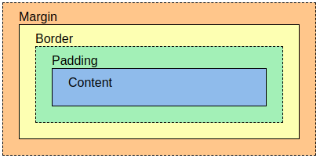

Explanation of the different parts:

* **Content** - The content of the box, where text and images appear
* **Padding** - Clears an area around the content. The padding is transparent
* **Border** - A border that goes around the padding and content
* **Margin** - Clears an area outside the border. The margin is transparent

The box model allows us to add a border around elements, and to define space between elements.

**8. What are the different types of CSS Selectors?**

CSS selectors are used to "find" (or select) the HTML elements you want to style.

We can divide CSS selectors into five categories:

* Simple selectors (select elements based on name, id, class)
* [Combinator selectors](https://www.w3schools.com/css/css_combinators.asp) (select elements based on a specific relationship between them)
* [Pseudo-class selectors](https://www.w3schools.com/css/css_pseudo_classes.asp) (select elements based on a certain state)
* [Pseudo-elements selectors](https://www.w3schools.com/css/css_pseudo_elements.asp) (select and style a part of an element)
* [Attribute selectors](https://www.w3schools.com/css/css_attribute_selectors.asp) (select elements based on an attribute or attribute value)

p {  
  text-align: center;  
  color: red;  
}

#para1 {  
  text-align: center;  
  color: red;  
}

.center {  
  text-align: left;  
  color:blue;  
}

p.center {  
  text-align: center;  
  color: red;  
}

* {  
  text-align: center;  
  color: blue;  
}

**9. Define Doctype.**

The HTML document type declaration, also known as DOCTYPE, is the first line of code required in every HTML or XHTML document. The DOCTYPE declaration is an instruction to the web browser about what version of HTML the page is written in. This ensures that the web page is parsed the same way by different web browsers.

**10. Explain 5 HTML5 semantic tags.**

Elements such as <header>, <footer> and <article> are all considered semantic because they accurately describe the purpose of the element and the type of content that is inside them.

The semantic elements added in HTML5 are:

* <article>
* <aside>
* <details>
* <figcaption>
* <figure>
* <footer>
* <header>
* <main>
* <mark>
* <nav>
* <section>
* <summary>
* <time>

**<header>**

The <header> element is generally found at the top of a document, a section, or an article and usually contains the main heading and some navigation and search tools.

**<footer>**

If there is a <header> there must be a <footer>. A <footer> is generally found at the bottom of a document, a section, or an article. Just like the <header> the content is generally meta information, such as author details, legal information, and/or links to related information.

**<small>**

The <small> element often appears within a <footer> or <aside> element which would usually contain copyright information or legal disclaimers, and other such fine print. However, this is not intended to make the text smaller. It is just describing its content, not prescribing presentation.

**<time>**

The <time> element allows an unambiguous ISO 8601 date to be attached to a human-readable version of that date.

**<figure> and <figcaption>**

<figure> is for wrapping your image content around it, and <figcaption> is to caption your image.

**12. Create HTML for form.png (check resources, highest weightage for answers)**

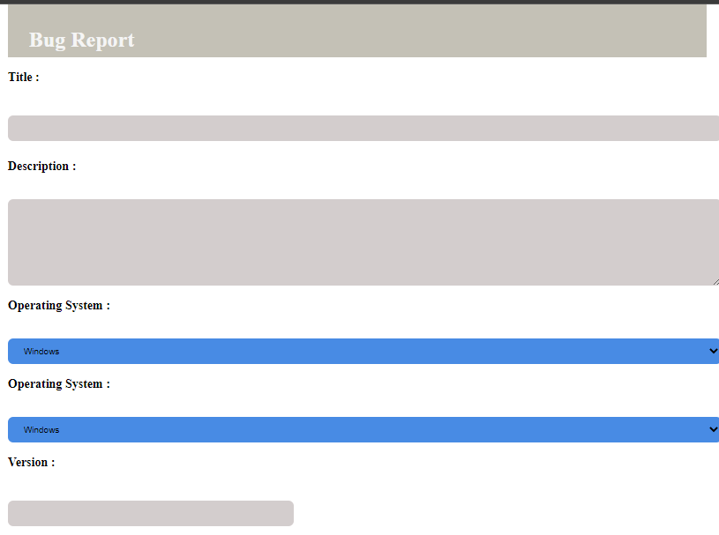

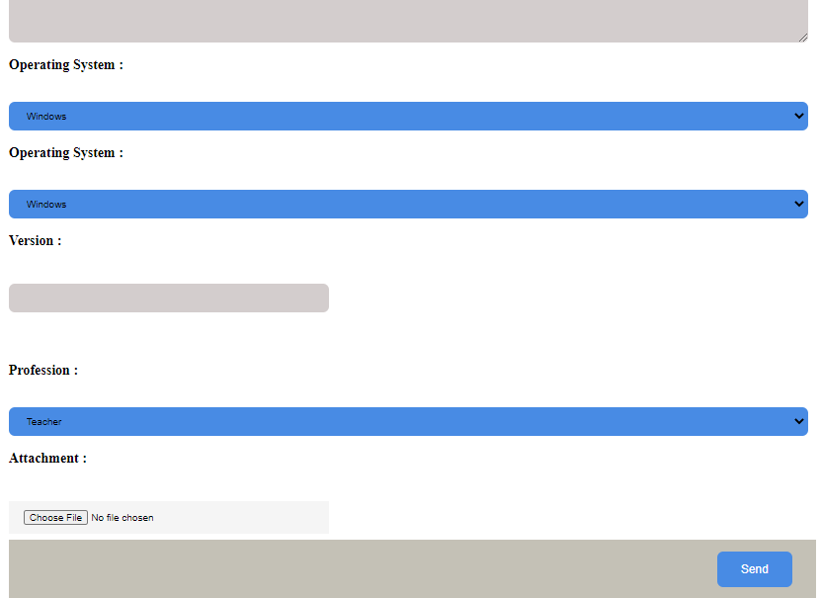

**11. Create HTML for web-page.jpg (check resources, highest weightage for answers)**

<html>

    <head>

        <title>HTML FORM</title>

        <style>

        input

        {

            width: 100%;

            padding: 12px 20px;

            margin: 8px 0;

            background-color:rgb(72, 139, 228);

        }

        select

        {

            width: 100%;

            padding: 12px 20px;

            border: none;

            background-color: rgb(72, 139, 228);

            border-radius: 8px;

        }

        #titl

        {

            background-color:rgb(211, 205, 205);

            border-radius: 8px;

            border: 1px;

        }

        #desc

        {

            background-color:rgb(211, 205, 205);

            border-radius: 8px;

            border: 5px;

            width: 100%;

        }

        #ver

        {

            background-color:rgb(211, 205, 205);

            border-radius: 8px;

            border: 1px;

        }

        #myfile

        {

            background-color:whitesmoke;

            width: 40%;

        }

        #head

        {

            background-color:rgb(71, 63, 63);

            color:whitesmoke;

        }

        #vers

        {

            width: 40%;

            border: 1px;

        }

        .container

        {

           display: block;

           position: relative;

           padding-left: 35px;

           margin-bottom: 12px;

           cursor: pointer;

           font-size: 20px;

           border: 1px;

        }

        .button

        {

           float:right;

           background-color: rgb(72, 139, 228) ;

           border-radius: 8px;

           border: none;

           color: white;

           padding: 15px 32px;

           text-align: center;

           text-decoration: none;

           display: inline-block;

           font-size: 16px;

           align-self: baseline;

        }

        header

        {

           background-color: rgb(196, 193, 182) ;

           color: whitesmoke;

           padding: 15px 32px;

           text-align: left;

           display: inline-block;

           font-size: 16px;

           align-self: baseline;

           width: 92%;

           height: 50px;

        }

        footer

        {

           background-color: rgb(196, 193, 182) ;

           color: whitesmoke;

           padding: 15px 32px;

           text-align: left;

           display: inline-block;

           font-size: 16px;

           align-self: baseline;

           width: 95%;

           height: 50px;

        }

        html, body

        {

           margin : 0;

           padding : 0;

        }

        .myDiv

        {

           position: absolute;

           left: 20%;

           right: 20%;

        }

        </style>

    </head>

    <div class="myDiv">

    <header><h1>Bug Report</h1></header>

    <form id="form">

        <label for="titl"><h3>Title :</h3></label><br>

        <input type="text" id="titl" name="title"><br>

        <h3>Description : </h3><br>

       <textarea id="desc" name="desc" rows="8" >

       </textarea>

        <br>

        <label for="OS"><h3>Operating System :</h3></label><br>

        <select name="OS" id="OPS">

            <option value="Windows">Windows</option>

            <option value="Linux">Linux</option>

            <option value="MAC Os">MAC</option>

        </select>

        <br>

        <label for="cars"><h3>Operating System :</h3></label><br>

        <select name="cars" id="cars">

            <option value="Windows">Windows</option>

            <option value="Linux">Linux</option>

            <option value="MAC Os">MAC</option>

        </select>

        <br>

        <div id ="vers">

        <label for="ver"><h3>Version :</h3></label><br>

        <input type="text" id="ver" name="version"><br>

        <br>

        </div>

        <br>

        <label for="prof"><h3>Profession :</h3></label><br>

        <select name="prof" id="prof">

            <option value="volvo">Teacher</option>

            <option value="saab">Working</option>

            <option value="saab">Student</option>

        </select>

        <br>

        <label for="myfile"><h3>Attachment :</h3></label><br>

        <input accept="file_extension|audio/*|video/*|image/*|media_type" type="file" id="myfile" name="myfile">

        <br>

        <footer><button class ="button" type="submit" form="form" value="Submit">Send</button></footer>

    </div>

      </form>

</html>

<!DOCTYPE html>

<html>

    <head>

        <title>

            To The New

        </title>

        <link rel="stylesheet" href="qstyle.css">

    </head>

    <body>

        <header class="header1">

            <h1>

                TO THE NEW

            </h1>

            <div class="topnav">

                <a class="active" href="#home">Home</a>

                <a href="#news">News</a>

                <a href="#contact">Contact</a>

                <a href="#about">About</a>

              </div>

        </header>

            <div class="firstdiv">

                <div class="seconddiv">

                </div>

                <div class="thirddiv">

                </div>

                <div class="fourthdiv">

                </div>

                <div class="fifthdiv">

                </div>

                <div class="sixthdiv">

                </div>

                <div class="seventhdiv">

                    <p>Yes to the new is a very good company to join because of better work culture and great mentors</p>

                </div>

                <div class="eightdiv">

                    <h4>LATEST FROM THE GALLERY</h4>

                </div>

                <div class="ninthdiv">

                </div>

                <div class="tenthdiv">

                </div>

                <div class="elevendiv">

                </div>

                <div class="twelvediv">

                </div>

            </div>

        <footer>

            <p>Copyright@2007-2020 ~ All rights reserved</p>

        </footer>

    </body>

</html>

*{

background-color: black;

}

.header1 h1{

color: grey;

font-style: bold;

margin-left: 50px;

}

.firstdiv{

background-color: antiquewhite;

height: 1000px;

width: 1350px;

margin-left: 55px;

position: relative;

}

.seconddiv{

background-color:black;

border-radius: 2px;

position: absolute;

height: 360px;

width: 960px;

left:200px;

top: 35px;

}

.thirddiv{

height: 315px;

width: 215px;

background-color: black;

position: absolute;

top: 600px;

left: 200px;

}

.fourthdiv{

height: 315px;

width: 215px;

background-color: black;

position: absolute;

top: 600px;

left: 450px;

}

.fifthdiv{

height: 315px;

width: 215px;

background-color: black;

position: absolute;

top: 600px;

left: 700px;

}

.sixthdiv{

height: 315px;

width: 215px;

background-color: black;

position: absolute;

top: 600px;

left: 950px;

}

.seventhdiv{

width: 960px;

height: 80px;

background-color: lightgrey;

left: 200px;

top: 425px;

position: absolute;

}

.seventhdiv p{

color: white;

background-color: lightgrey;

}

.eightdiv{

background-color: antiquewhite;

top: 525px;

left: 200px;

position: absolute;

}

.eightdiv h4{

color:white;

background-color: lightgray;

}

.topnav {

background-color:black;

overflow: hidden;

margin: 37px;

}

.topnav a {

float:left;

color: #f2f2f2;

text-align: center;

padding: 14px 16px;

text-decoration: none;

font-size: 17px;

}

.ninthdiv{

background-color: grey;

top: 925px;

left: 200px;

width: 215px;

height:10px;

position: absolute;

}

.tenthdiv{

background-color: grey;

top: 925px;

left: 200px;

width: 215px;

height:10px;

position: absolute;

left: 450px;

}

.elevendiv{

background-color: grey;

top: 925px;

left: 200px;

width: 215px;

height:10px;

position: absolute;

left: 700px;

}

.twelvediv{

background-color:grey;

top: 925px;

left: 200px;

width: 215px;

height:10px;

position: absolute;

left: 950px;

}

footer{

color: white;

font-style: italic;

text-align: center;

}